Sample 1: formatting Abstract
Tough biodegradable hydrogel scaffolds prepared by stereolithography
Bas Van Bochove¹, Erwin Zant¹, Dirk W Grijpma^{1,2}
¹Department of Biomaterials Science and Technology, MIRA Institute for Biomedical Technology and Technical Medicine, University of Twente, Enschede, Netherlands; ²Department of Biomedical Engineering, University of Groningen, University Medical Centre Groningen, W.J. Kolff Institute, Groningen, Netherlands
Introduction: Combinatorial chemistry allows for simultaneous preparation of a large number of different synthetic polymeric materials. Using mixtures of poly(trimethylene carbonate) (PTMC)-, poly(D,L-lactide) (PDLLA)-, poly(ethylene glycol) (PEG)- and poly(􀀀-caprolactone) (PCL)- dimethacrylate (dMA) functionalized macromers we prepared 255 different networks with widely differing properties at the same time. Of these networks, several hydrogels with high water-uptake, excellent mechanical properties and very good cell adhesion and proliferation were identified[1]. Stereolithography (SLA) is a rapid-prototyping technique that allows the manufacturing of designed 3D structures using photo-crosslinkable macromers.Here we prepared mixed-macromer hydrogel network films with excellent mechanical properties as well as designed hydrogel scaffolds by SLA.
Materials and methods: Linear TMC- or DLLA- oligomers (molar mass 4 or 10 kg/mol) were prepared by ring-opening polymerization of TMC- or DLLA monomers. dMA-functionalized TMC-, DLLA- and PEG macromers were prepared by functionalization of their respective oligomers with methacrylic anhydride.For mechanical testing, equal amounts of PTMC-dMA 4k, PDLLA-dMA 4k, PEG-dMA 4k, PTMC-dMA 10k and PEG-dMA 10k were dissolved in propylene carbonate (PC) containing 1 wt% Irgacure 2959 photoinitiator. Specimens of 5mm in height and 5mm in diameter and network films were prepared by casting, followed by photo-crosslinking, extraction and drying. Prior to mechanical testing, the specimens were equilibrated in water for 48h.For SLA, equal amounts of PTMC-dMA 4k, PDLLA-dMA 4k, PEG-dMA 4k, PTMC-dMA 10k and PEG-dMA 10k were dissolved in PC containing 5 wt% TPO-L photoinitiator and 0.15 wt% Orasol Orange dye. After building, the scaffolds were extracted and dried.
Results: The water uptake of the photo-crosslinked networks was 197 ± 18 wt%. The water-swollen hydrogels showed excellent compressive properties and did not fail during the compression test, the compressive modulus was 0.7 MPa. Interestingly, the hydrogels obtained their original dimensions after testing when placed in water. Furthermore, the hydrogels showed very good tensile properties: the tensile modulus was 1.27 MPa, the maximum tensile strength 0.72 MPa and the elongation at break 186%. These values are extraordinarily high for synthetic hydrogel networks with such a high water content.We also prepared designed mixed-macromer hydrogel scaffolds by SLA. See Figure 1. The scaffolds were prepared with very high control over the pore-size, porosity and architecture.
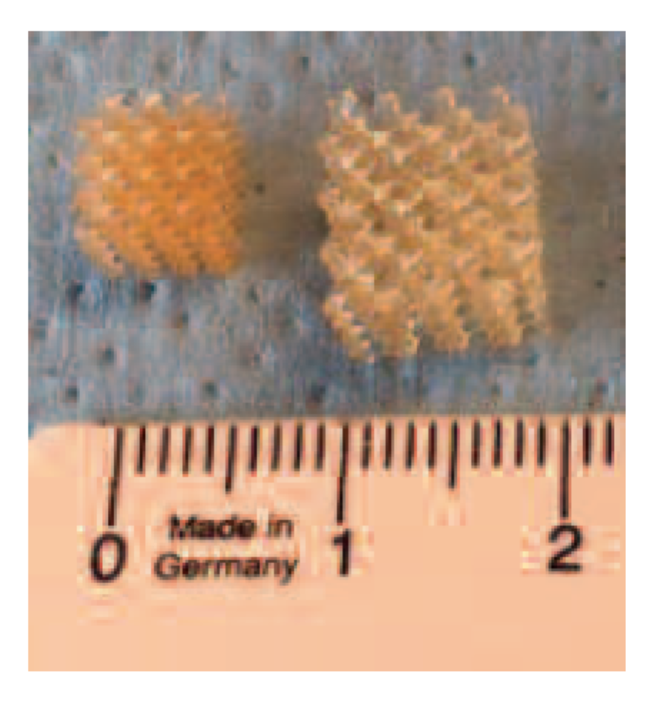
Figure 1. Porous hydrogel networks with designed pore structures prepared by stereolithography in the dry (left) and hydrated (right) state.
Conclusions: Tough, synthetic photo-crosslinked mixedmacromer hydrogels were prepared and their mechanical properties were evaluated. The structures showed high water uptake and had excellent mechanical properties. Porous hydrogel structures could readily be built by SLA, allowing the preparation of designed hydrogel scaffolds with extraordinary properties for biomedical applications and tissue engineering.
This work was supported by a grant from the Dutch government to the Netherlands Institute for Regenerative Medicine (NIRM, Grant No. FES0908).

